Master Thesis Outline Roland Roccaro

This document describes the outline of the Master Thesis of Roland Roccaro. This work is condocted with and for stakeholders at Swiss Post DWH LS OPS (Data warehouse Logistic Services Operations). The stakeholders define the standard reports to be used for all analytical reporting of all mail and parcel related workflows such as sorting, delivery etc.
It shows first the previous work, and then goes trough the research question, basis project management that will be applied. Following up with the current timeline trough out the Master Thesis using milestones and the outline of the chapters which are partly based on the project 1 and 2.

Study structure in regard to project structure.
The study programme consists of three different project works. These projects do not necessarily have to build on each other.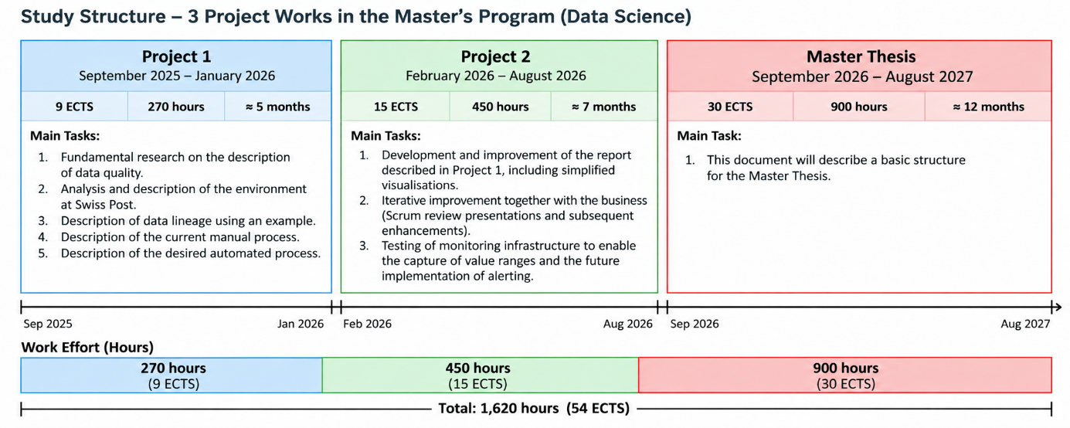
- Project 1. September 2025 to January 2026 9 ECTS / 270 hours
  - Fundamental research on the description and concepts of data quality.
  - Analysis and description of the relevant environment at Swiss Post.
  - Description of the data lineage using an example.
  - Description of the current manual process.
  - Description of the desired automated process.
- Project 2. February 2026 to August 2026 15 ECTS / 450 hours
  - Development and improvement of the report described in Project 1, including the development of several simplified visualisations.
  - Iterative improvement in collaboration with business stakeholders, including Scrum Review presentations and subsequent improvements.
  - Testing of monitoring infrastructure to enable the collection of value ranges and support future alerting.
- Master Thesis. September 2026 to August 2027 30 ECTS / 900 hours
  - This document describes the initial structure of the Master Thesis.

Research Question
Following research question is the core of this master thesis:
- To what extent can data quality in analytical reporting at DWH LS OPS be automatically validated at the reporting layer?

Hypothese
Based on the research question the following hypothesis are defined.
- Relevant data quality errors in analytical reporting can be systematically identified, classified, and documented by the responsible stakeholders.
- An automated data quality validation approach can reliably detect the documented error classes at the analytical reporting layer.

Research Method
The research is carried out in phases.
- The project starts with an initial research phase, during which a baseline and direction is established.
- The results are documented as baseline.
- During the course of the project when reaching relevant phases or milestones, additional research is performed to validate results.
- Furthermore, after completing the first iteration, further research confirming topics for a second iteration.

Project Management Method
The overall project management methods to be used during the master thesis. This does not mention all project management methods such as risk management.
- Overall Structure Based on Milestones
  - The milestones are used to structure the different stages of the research project, from the scientific foundation through implementation to the subsequent evaluation.
  - The milestones are defined at the beginning of the thesis.
  - They divide the work into blocks that provide an overall framework without predetermining the specific topics or approaches.
  - They also provide a basis for subsequently analysing and documenting the effort required for the individual work blocks.
- Weekly Meetings, Jour Fixe of Student and advisor
  - Ken as advisor and Roland as Student meet weekly for 1 hour
  - Topic of the meeting is:
    - Check-in, what is the project, what deliverables are done.
    - Which Deliverable am I working on?
    - State of the Deliverable
    - Next Steps
    - Other
  - Uppon reaching milestones or other specific dates, the topics can vary.
  - The expert has been invited to the meeting as optional.
- Agile Project Management using Scrum.
  - Two-week sprints. Every uneven week number sprints start and end.
  - The sprints are synchronised with those of the Swiss Post DWH LS OPS teams.
  - Sprint planning is conducted together with the relevant Swiss Post stakeholders.
  - The planning is reviewed and confirmed during the biweekly Jour Fixe meetings.
  - Scrum Reviews take place every four weeks within DWH LS OPS. These meetings can also be used to present and discuss the progress of the Master Thesis.
f. Scrum.
  - Retrospectives take place every two weeks within the DWH LS OPS teams.
g. Within the academic team, retrospectives are planned upon completion of each milestone.

Phases / Milestones
The following phase are defining blocks which can be closed after completing each and move on. The conclusion and start of each phase are used to review and adapt the current state.
The milestones are events during the course of the phases. Each milestone will be documented if it has been reached in time. Furthermore, any adaptions required to the milestone plans have to be documented.
- Phase 1, Research
  - Refine the problem statement.
  - Define and narrow the scope.
  - Define the use case.
    - Milestone 1, use case defined.
  - Conduct the literature review.
  - Define the basic outlines for P2 to P3 and specify possible alternatives.
  - Closure conditions:
    - Research based on problem statement initially closed.
    - Basis for P2 and P3 defined.
    - Methodology for thesis defined.
    - Review of baseline document parts from project 1 and 2 performed.
- Phase 2, Define the Baseline with Stakeholders
  - Adapt M2 based on the findings from P1.
  - Document the current stakeholder knowledge regarding error detection.
    - Milestone 2, Stakeholder meetings held.
  - Attempt to systematically identify and document relevant errors.
  - Define how the results will be evaluated against future iterations.
    - Milestone 3, Error documentation by stakeholders started.
  - Closure Conditions
    - Stakeholder knowledge documented
    - Stakeholders have means to document errors.
    - Defined test window during which manual and automatic errors are compared.
    - Error documentation setup so that it is comparable to future Phase 3 implementation.

- Phase 3, First Iteration
  - Review the results of P2 and adapt P3 accordingly.
  - Define a minimal outline of the P3 objective while keeping the specific approach open to findings from the preceding research.
    - Milestone 4, Development environment set, initial setup of tools
  - Develop the first/basic implementation.
    - Milestone 5, MVP has been setup.
  - Summarise the results.
    - Milestone 6, MVP presented to Post stakeholders.
  - Closure conditions
    - The development environment is setup.
    - Permissions required to work have been setup
    - The MVP is setup and running.
    - Data for test window retrieved.
    - The Post stakeholders received presentation of current state.
    - Defined test slot and registered test results
- Phase 4, Second Iteration
  - Review the achievement of the objectives from P3 and, if necessary, pursue an alternative approach.
    - Milestone 7, Outline of second iteration defined.
  - Define a minimal outline of the phase objective while keeping the specific approach open to findings from the preceding research.
  - Develop an adapted implementation.
  - Summarise the results.
  - Closure conditions
    - Second iteration outline defined.
    - Data for test window retrieved.
- Phase 5, Comparative Evaluation
  - Compare the results of all investigated approaches.
    - Milestone 8, Data of different approaches compared.
  - Identify factors that may limit a direct or fair comparison, including specific differences between the approaches.
- Phase 6, Analysis of Goal Achievement and Thesis Finalisation
  - Describe which objectives were achieved and which were not.
  - Finalise the thesis document.
    - Milestone 9, Thesis document completed.
  - Finalise the required deliverables:
    - Video
    - Poster
    - Presentation and Defence
  - Milestone 10, Presentation ready
  - Thesis document delivered
  - Presentation held

Milestones Timeline
The milestone timelines are setup as follows before project start.

- Milestone 1, use case defined.
  - 18.10.2026
- Milestone 2, Stakeholder meetings held.
  - 15.11.2026
- Milestone 3, Error documentation by stakeholders started.
  - 29.11.2026
- Milestone 4, Development environment set, initial setup of tools
  - 13.12.2026
- Milestone 5, MVP has been setup.
  - 21.03.2027
- Milestone 6, MVP presented to Post stakeholders.
  - 04.04.2027
- Milestone 7, Outline of second iteration defined.
  - 18.04.2027
- Milestone 8, Data of different approaches compared.
  - 16.05.2027
- Milestone 9, Thesis document completed.
  - 11.07.2027
- Milestone 10, Presentation ready
  - 25.07.2027

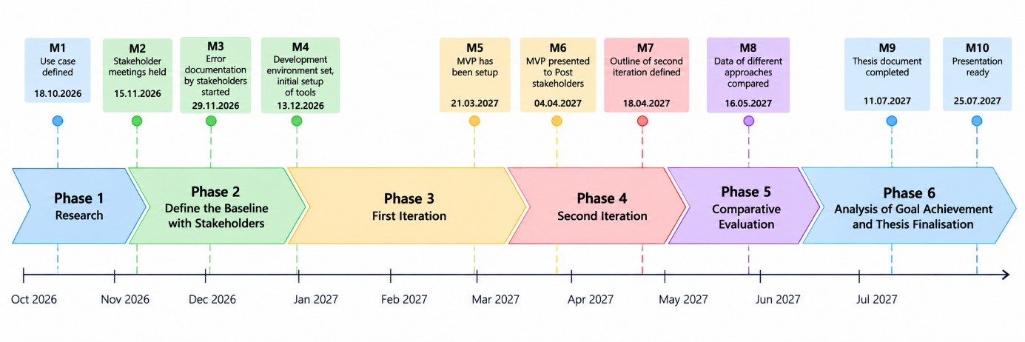

Chapter Structure
The chapter structure is a basic outline taken from projects 1 and 2 including additional topics for the master thesis such as the description of the milestones. Some existin content is to be [changed] or [renewed] which is shown in [brackets].

Contents

Abstract

1. Introduction
1.1. Background
1.2. Motivation
1.3. Problem Statement
1.4. Scope and Boundaries
1.5. Expected Outcome
1.6. Structure of the Document

2. Project Management
2.1. Team Constellation
2.2. Project Management Methodologies
2.2.1. Agile and Iterative Approach [CHANGED]
2.2.2. Project Plan and Work Packages [NEW]
2.2.3. Milestones [CHANGED]
2.3. Tools to Support Project Management
2.4. Time Tracking and Effort Planning [CHANGED]
2.5. Risk Management

3. Topic of this Research
3.1. Previous Research and Problem Statement [CHANGED]
3.1.1. Project 1 – Conceptual and Analytical Foundation [NEW]
3.1.2. Project 2 – DQM Implementation and Validation [NEW]
3.1.3. Problem Generalisation for the Master Thesis [NEW]

3.2. Research Gap [CHANGED]

3.3. Research Objective [NEW]

3.4. Research Question [CHANGED]

3.5. Research Hypotheses [NEW]

3.6. Research Methodology [NEW]
3.6.1. Research Approach
3.6.2. Comparison of Detection Approaches
3.6.3. Experimental Design
3.6.4. Evaluation Criteria and Metrics

3.7. Success Definition [CHANGED]

3.8. S.M.A.R.T. Goals [CHANGED]

3.9. Expected Contributions [NEW]
3.9.1. Practical Contribution
3.9.2. Scientific Contribution

3.10. Expected Benefits for the Reporting Solution [CHANGED]

4. Solution Landscape
4.1. Data Quality Management at Swiss Post
4.2. Existing Rule-Based DQM Initiative
4.3. Heterogeneous Sorting Centre Environments
4.4. Data Lineage
4.5. Existing Reporting Pipeline
4.6. Existing Data Quality Reporting and Visualisation
4.7. Existing DQM Platform and Infrastructure [CHANGED]
4.8. Baseline for the Master Thesis [NEW]

5. Implementation
5.1. Technical and Experimental Setup [CHANGED]

5.2. First Basic Detection Approach (Eventually Rule based) [CHANGED]
5.2.1. Design
5.2.2. Implementation
5.2.3. Technical Validation

5.3. Improved Detection methods, (Statistical? Different tools? My very own implementation) [NEW]
5.3.1. Design
5.3.2. Implementation
5.3.3. Technical Validation

5.4. Advanced Detection Approach, (ML/Own / Extended first second approach / New Ideas… alternative implementation when 1 2 failed) [NEW]
5.4.1. Selection of Approach
5.4.2. Design
5.4.3. Implementation
5.4.4. Technical Validation

6. Results
6.1. Introduction
6.2. Evaluation Criteria and Experimental Conditions [CHANGED]
6.3. Rule-Based Approach Results [CHANGED]
6.4. Statistical Approach Results [NEW]
6.5. Advanced / Machine-Learning Approach Results [NEW]
6.6. Comparative Evaluation [NEW]
6.7. Practical / Stakeholder Evaluation [NEW]
6.8. Summary

7. Discussion [CHANGED]
7.1. Interpretation of Results [NEW]
7.2. Evaluation of Research Hypotheses [NEW]
7.3. Answer to the Research Question [NEW]
7.4. Comparison with Existing Research [NEW]
7.5. Practical Implications [NEW]
7.6. Generalisability of the Results [NEW]
7.7. Threats to Validity and Limitations [NEW]

8. Conclusion and Outlook [CHANGED]
8.1. Summary of Findings
8.2. Scientific Contribution
8.3. Practical Contribution
8.4. Future Work

9. Statement of Authorship

List of Figures
List of Tables
Glossary
Bibliography

Appendices
A. Queries and Technical Artefacts
B. Project and Experiment Documentation
C. Risk Monitoring
D. Supplementary Experimental Results
E. Stakeholder Evaluation Material

